MAIN MENU

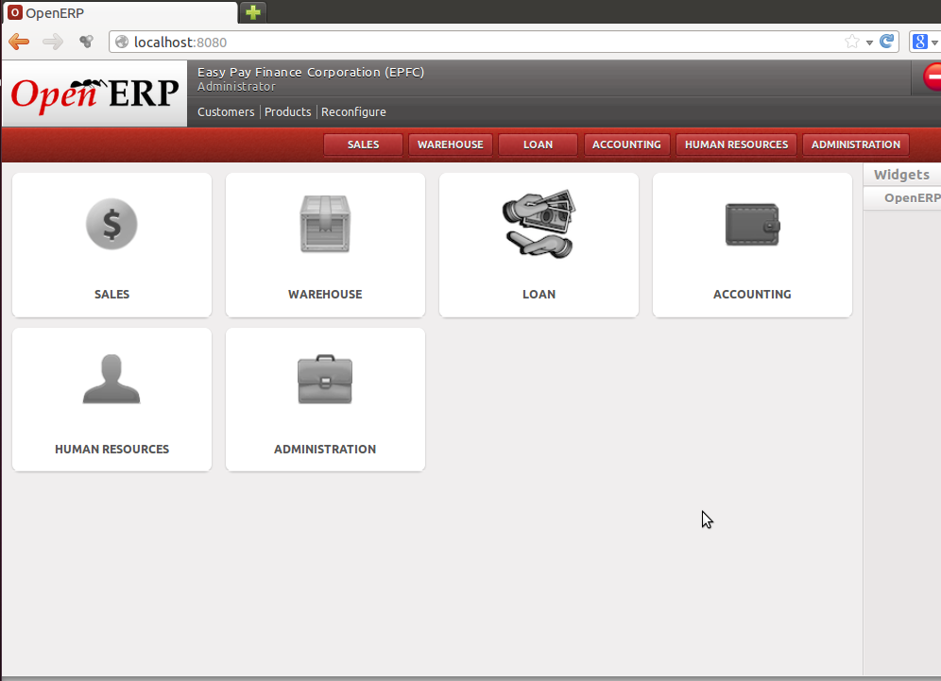
This is the sample snapshot of the main menu. Only the modules you are given access to will appear. For the rest of this user's manual, we will be using mainly the LOAN and ACCOUNTING modules.

